AI-Based Clinical Conversation Intelligence System
(For Chiropractic, Manual Osteopathy, Soft Chiropractic Therapy, Ayurveda and Panchakarma Clinic)

A Specialized Clinic Treating Muscle Pain, Nerve Compression, Spine Disorders, Slipped Disc, Joint Stiffness, Soft Tissue Injury, Bone Alignment, Sciatica, Cervical & Lumbar Pain

Prepared by:

TechRitzy Pvt Ltd

AI Solution Architect
Date: 31 March 2026
Version: 1.0

Chapter-1: Project Overview
_______________________________________________________________________
1. Executive Summary
This project proposes a comprehensive web-based AI-powered clinical management system tailored for a specialized clinic handling musculoskeletal, neurological and spine-related conditions. The system digitizes patient registration, pain assessment, consultations, treatments, doctor-patient conversations and progress tracking while embedding AI/ML capabilities for clinical conversation intelligence, predictive analytics, personalized therapy recommendations and risk detection.
The solution will be built using Streamlit for an intuitive, clinician-friendly interface with a relational database backend. It transforms unstructured clinical notes and conversations into structured, AI-ready data, enabling predictive insights and improving treatment outcomes.
Key Benefits:

Structured data collection for immediate clinical use and future AI training.
- Automated AI analysis of conversations and symptoms.
- Real-time dashboard for patient history and progress tracking.
- Reduced manual paperwork and faster decision-making.
- Scalable foundation for advanced ML models (pain prediction, surgery risk, therapy recommendation).
2. Purpose
The system is customized for clinics treating:
- Muscle pain
- Nerve compression
- Spine disorders
- Slip disc (L1–L2, L4–L5, etc.)
- Joint stiffness
- Soft tissue injury
- Bone alignment
- Sciatica
- Cervical and lumbar pain
- Manual Osteopathy
- Soft Chiropractic Therapy
- Ayurveda and Panchakarma treatment

It collects both structured (forms) and unstructured (transcripts, notes) data to power AI/ML applications, including:
- Clinical conversation intelligence
- Patient condition prediction
- Treatment recommendation
- Pain severity analysis
- Progress tracking
- Risk detection
- Personalized therapy suggestions

3. Problem Statement
The clinic currently manages patient information, spine and muscle examinations, therapy sessions and doctor–patient conversations manually using paper notes, memory, WhatsApp messages, or unstructured files. Because of this:

- Patient history is difficult to retrieve quickly during follow-ups.
- Different visits are not linked systematically, leading to fragmented records.
- Clinical conversations are not captured or analyzed for deeper insights.
- Data is not structured for AI/ML, missing opportunities for predictive analytics, personalized recommendations and early risk detection.
- Manual processes cause delays in treatment planning, higher error rates and suboptimal patient outcomes.

4. Proposed Solution – System Modules
The system comprises eight core modules with the exact forms specified:

4.1 Patient Registration Form
Key Fields:
- Patient ID (auto),
- Full Name,
- Age, Gender,
- DOB,
- Mobile,
- Email,
- Occupation,
- Height,
- Weight,
- BMI (auto),
- Address,
- Lifestyle,
- Smoking/Alcohol,
- Existing Diseases,
- Previous Spine Injury/Surgery,
- Emergency Contact,
- Date Added (auto).
Buttons: Add Patient, Clear, View, Edit, Delete.
4.2 Pain & Body Area Assessment Form
Key Fields:
- Assessment ID (auto),
- Patient ID,
- Main Problem,
- Pain Area (multi-select with body diagram),
- Spine Level,
- Pain Severity (0–10 slider),
- Pain Type, Duration,
- Triggering Activity, Movement Limitation, Numbness, Muscle Weakness,
- Nerve Pain Radiation, Sleep Disturbance, Posture Problem,
- Stress Level (1–10).
4.3 Consultation & Examination Form
Key Fields:
- Consultation ID (auto), Patient ID, Doctor Name, Specialization, Date/Time,
- Chief Complaint,
- Clinical Findings, Spine/Muscle/Nerve/Tissue/Bone-Joint Examination,
- Preliminary Diagnosis,
- Recommended Scan,
- Uploaded Reports,
- Follow-up Date.
4.4 Therapy / Treatment Form
Key Fields:
- Treatment ID (auto), Consultation ID,
- Therapy Type (multi-select), Chiropractic Adjustment Area, Soft Tissue Therapy,
- Nerve Handling Technique,
- Muscle Therapy, Bone Alignment Correction,
- Ayurveda Medicine, Panchakarma Type, Oil Used,
- Home Exercise, Posture Advice,
- Session Duration, Session Outcome.
4.5 Doctor–Patient Conversation Capture Form
Key Fields:
- Conversation ID (auto), Consultation ID,
- Source (Manual/Audio), Audio File Upload,
- Raw Transcript, Language, Speaker Separation,
- Emotional State, Pain Keywords (auto-detected), Additional Notes, Timestamp.
- Example Transcript Handling: Supports English/Hindi/Mixed with speaker labels.
4.6 AI / ML Output Form
Key Fields:
- AI Result ID (auto), Conversation ID, AI Summary,
- Extracted Symptoms, Body Area Detected, Possible Condition, Pain Severity Predicted, Recommended Therapy, Recommended Tests,
- Suggested Ayurveda Treatment,
- Risk Level, Surgery Probability (%), Recovery Time Prediction,
- Follow-up Suggestion, AI Confidence Score (%),
4.7 Progress Tracking Form
Key Fields:
- Progress ID (auto), Patient ID,
- Session Number, Date,
- Previous/Current Pain Score, Mobility/Sleep/Numbness Improvement,
- Patient Feedback
- Practitioner Remark.
4.8 Dashboard / Patient History Screen

Task | Activity
Search | By Patient ID, Name, Mobile, Pain Area, Slip Disc Level.
Summary Card | Name, Age, Occupation, Main Pain Area, Current Pain Score,  Sessions, Latest Diagnosis, Recovery Status.
History Table | Date | Condition | Therapy | Pain Score | Improvement.
Detailed View (on click) | Consultation notes, full transcript, uploaded scans, AI diagnosis, treatment and improvement trend graph.

5. System Architecture
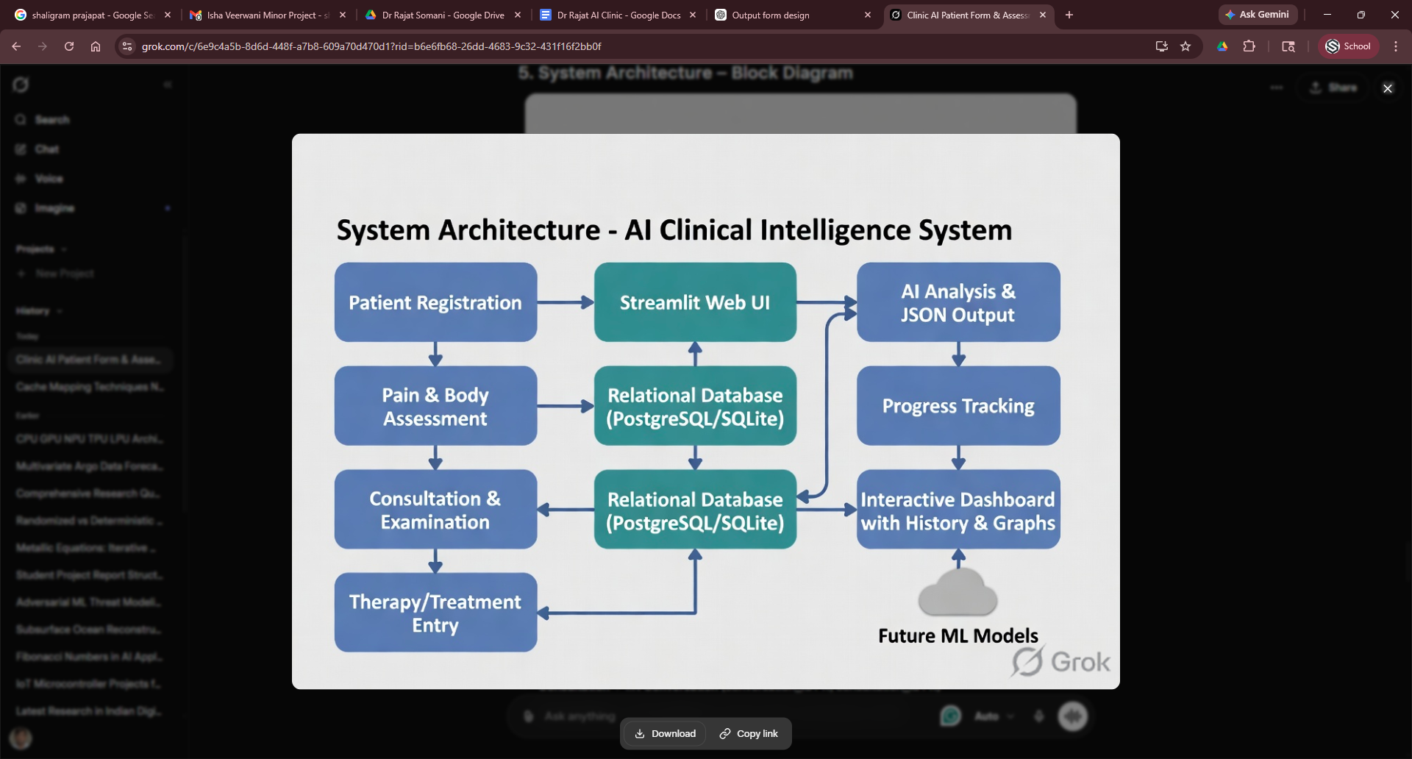
6. Sample Database Design – ER Diagram
Relationships
Patient (patient_id PK)→ 1:N Pain_Assessment (assessment_id PK, patient_id FK)
Patient (patient_id PK)→ 1:N Consultation (consultation_id PK, patient_id FK)
Patient (patient_id PK)→ 1:N Progress (progress_id PK, patient_id FK)
Consultation → 1:N Treatment (treatment_id PK, consultation_id FK)
Consultation → 1:N Conversation (conversation_id PK, consultation_id FK)
Conversation → 1:1 AI_Output (ai_result_id PK, conversation_id FK)
Entity Details :
Patient (patient_id, name, age, gender)
Pain_Assessment( assessment_id, patient_id, pain_area, severity)
Consultation( consultation_id, patient_id, diagnosis)
Treatment(treatment_id, consultation_id, therapy_type)
Conversation( conversation_id, consultation_id, transcript)
AI_Output( ai_result_id, conversation_id, json_output, risk_level)
Progress( progress_id, patient_id, pain_score_before/after)
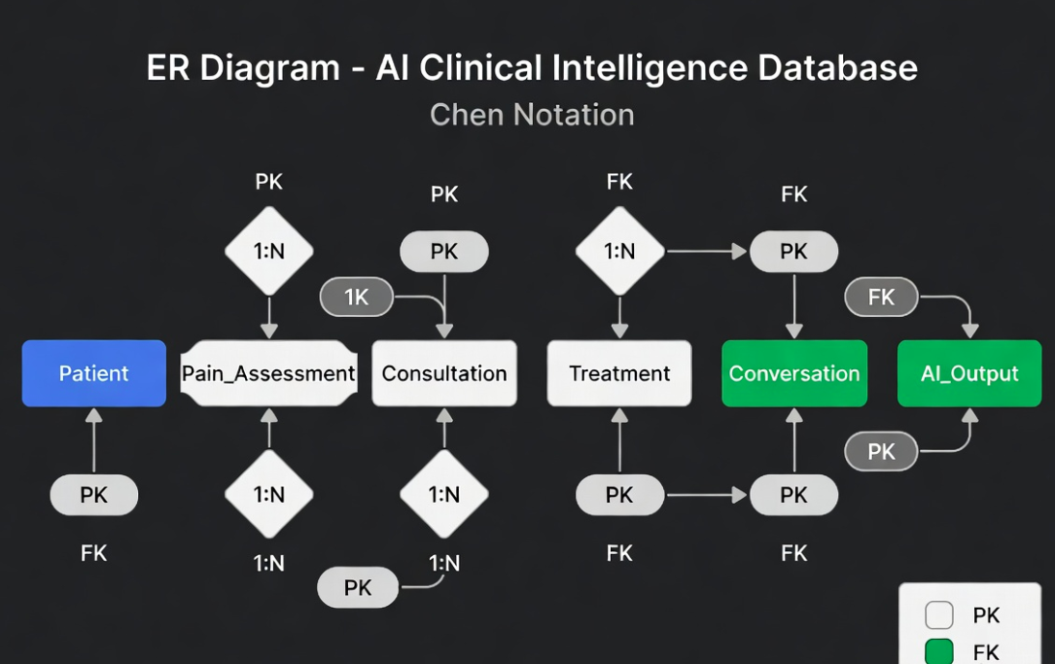

7. AI/ML Decision Tree – Risk Detection & Therapy Recommendation
The system includes a built-in decision tree logic (initially rule-based, later replaceable with a trained ML model) for real-time AI outputs.

This decision tree will be implemented initially as if-else rules in Python and later trained on collected data using scikit-learn or similar.

8. User Interface – Streamlit Sidebar Layout
Sidebar Navigation:
- Add Patient
- Pain Assessment
- Consultation Entry
- Treatment Session
- Upload Conversation
- AI Analysis
- Progress Tracker
- Dashboard / History

All forms will be implemented as Streamlit pages with real-time validation, auto-calculations (BMI), file uploadsand audio transcription preview.

9. Technology Stack (Proposed)

Frontend/UI | Streamlit (Python)
Backend | Python 3.12
Database | PostgreSQL (or SQLite for MVP)
AI/ML
NLP/Transcription | Whisper (local) or OpenAI Whisper API
LLM for summary & JSON | Grok / Llama-3 / GPT-4o-mini
Decision Tree / Predictive Models | scikit-learn (future)
Implementation
Deployment | Streamlit Community Cloud or Docker + AWS/Heroku
Storage | Local filesystem for audio/reports

10. AI/ML Features (Phase 2 – Built on Collected Data)
- Pain severity prediction model
- Slip disc risk detection model
- Therapy recommendation engine
- Automatic symptom extraction from conversation
- AI-based follow-up reminder system
- Recovery time prediction
- Personalized exercise suggestion system
- Patient classification (mild/moderate/severe)
Early detection of surgery candidates

11. Implementation Roadmap

Phase | Duration | Output
Phase 1 | (4 weeks) | Forms, Database, Dashboard
Phase 2 | (3 weeks) | Conversation capture + basic AI summary
Phase 3 | (4 weeks) | Full AI decision tree + JSON outputs
Phase 4 | (Ongoing) | Train custom ML models on collected data

Total MVP Timeline: 8–10 weeks

12. Conclusion
This AI-Based Clinical Conversation Intelligence System will digitize and intelligently enhance every aspect of clinic operations while creating a rich dataset for continuous AI improvement. It directly addresses the current pain points of manual processes and positions the clinic as a technology-forward leader in chiropractic, osteopathy and Ayurvedic care.
Next Steps:

- Presentation and Approval of proposal
- Requirement sign-off on forms
- Development kick-off

Chapter-2 - Start
_______________________________________________________________________
We are dividing the project into 8 independent modules that can be developed in parallel by different teams.
Team Composition
Team No | Team Name | Size | Lead Role
Team A | Patient Management Team | 3 | Senior Backend Dev
Team B | Clinical Assessment Team | 4 | Full Stack Developer
Team C | Treatment & Progress Team | 3 | Backend + Streamlit
Team D | Conversation & AI Integration Team | 5 | AI/ML Engineer
Team E | Dashboard & UI/UX Team | 4 | Streamlit and UI Expert
Team F | Database & Architecture Team | 2 | DBA / Architect
Team G | Testing & QA Team | 3 | QA Lead
Team H | DevOps & Deployment Team | 2 | DevOps Engineer

Independent Module Assignments
Module 1: Patient Management System
Assigned To: Team A Effort: 3 weeks
Scope:
- Patient Registration Form (all fields + validation)
- Auto Patient ID generation
- BMI auto-calculation
- CRUD operations (Add, View, Edit, Delete)
- Basic search (Name, Mobile, ID)
Deliverables:
- Complete Patient CRUD API + Streamlit pages
- Patient model in database
Dependencies: Database Module

Module 2: Pain & Body Area Assessment
Assigned To: Team B Effort: 3 weeks
Scope:
- Pain & Body Area Assessment Form
- Multi-select body diagram (interactive)
- Pain severity slider, posture dropdowns, etc.
- Link with Patient ID
Deliverables:
- Assessment form with body map visualization
- Data validation & storage
Dependencies: Module 1 (Patient)

Module 3: Consultation & Examination
Assigned To: Team B Effort: 3.5 weeks
Scope:
- Consultation & Examination Form
- All clinical findings fields
- File upload (MRI/X-ray reports)
- Preliminary Diagnosis
- Follow-up date
Deliverables:
- Consultation entry system with file handling
Dependencies: Module 1

Module 4: Therapy & Treatment Management
Assigned To: Team C Effort: 3 weeks
Scope:
- Therapy / Treatment Form
- Multi-select therapy types (Chiropractic, Osteopathy, Panchakarma, etc.)
- Session details, medicines, exercises, outcome
Deliverables:
- Treatment session logging system
Dependencies: Module 3 (Consultation)

Module 5: Progress Tracking
Assigned To: Team C Effort: 2.5 weeks
Scope:
- Progress Tracking Form
- Pain score comparison
- Improvement metrics (Mobility, Sleep, Numbness)
- Practitioner remarks
Deliverables:
- Progress entry + history per patient
Dependencies: Module 1 & 4

Module 6: Conversation Capture & Transcription
Assigned To: Team D Effort: 4 weeks
Scope:
- Doctor–Patient Conversation Form
- Audio file upload
- Manual transcript entry
- Speaker separation
- Language support (English/Hindi)
- Pain keyword auto-detection
Deliverables:
- Conversation module with audio handling
Dependencies: Module 3 (Consultation)

Module 7: AI/ML Engine & Decision Intelligence
Assigned To: Team D Effort: 5 weeks (most critical)
Scope:
- AI / ML Output Form
- Rule-based Decision Tree implementation
- LLM integration (summary, JSON output, recommendations)
- Risk level, surgery probability, recovery prediction
- Structured JSON generation
- AI Confidence scoring
Deliverables:
- AI analysis pipeline
- Decision Tree logic
- Integration with Conversation module
Dependencies: Module 6

Module 8: Dashboard, History & Visualization
Assigned To: Team E Effort: 4 weeks
Scope:
- Main Dashboard
- Patient Search (multiple filters)
- Summary Cards
- History Table
- Detailed View (with graphs)
- Improvement trend charts
Deliverables:
- Complete interactive dashboard
Dependencies: All other modules

Cross-Cutting Modules (Shared)
Module | Assigned To | Effort | Responsibility
Database Design & ORM | Team F | 2 weeks | ER Diagram, PostgreSQL schema, relationships
System Architecture & APIs | Team F | 2 weeks | Overall structure, API design
Streamlit UI/UX Standardization | Team E | Ongoing | Common components, themes, validation
DevOps & Deployment | Team H | 2 weeks | Docker, Streamlit Cloud / AWS setup
Testing & Quality Assurance | Team G | 4 weeks | Unit, Integration, User Acceptance Testing

Module Dependencies Overview
Module 1: | Patient
Module 2: | Assessment
Module 3: | Consultation
Module 4: | Treatment
Module 6: | Conversation
Database Team
Module 7: | AI Engine
Module 8: | Dashboard

Development Approach
Weekly Sync: | Every Monday (All Team Leads)
Code Repository: | GitHub with separate branches per module
Integration Phase: | After Week 6 (All modules integrated)
MVP Release Target: | 10–11 weeks
Parallel Development: | Teams A, B, C, F can start immediately

